Nama Produk : TRANSISTOR CHECKER BASED ON DIRECTION OF CURRENT
FLOW
Jenis IP yang ingin di pohon : PATENT/COPYRIGHT/TRADEMARK/INDUSTRIAL DESIGN
Nota: Patent adalah perlindungan bagi produk atau proses yang baharu (novel), mempunyai langkah-langkah inovasi (inventive steps) dan boleh diaplikasikan di industri (industrially applicable) yang diberikan kepada inventor untuk tempoh 20 tahun.

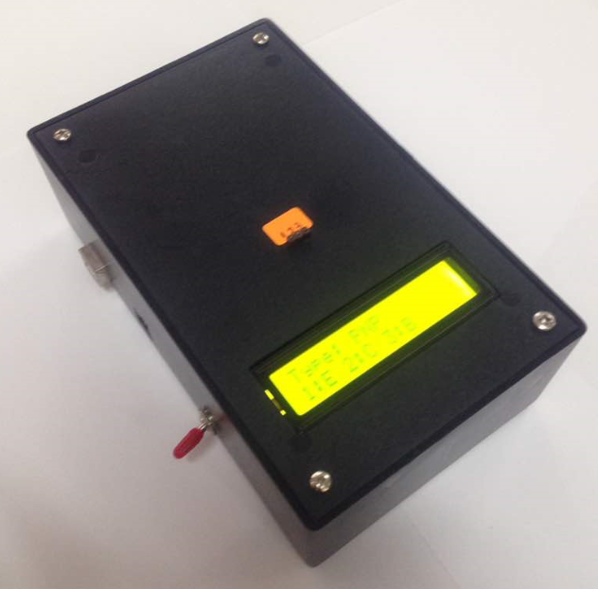

Rajah 1: Gambar Produk

- PENYATAAN MASALAH DAN OBJEKTIF KAJIAN

Problem Statement
Based on observation that we have done when the practical work that needs to use transistor as one of the components students having difficulty to finish their practical work on time. This is because not all students have ability to use multi meter to determine the pin layout of the transistor and they take long times to identify it. It is such a wasteful cause that time should be used to do other task but they just use it to identify the pin. Other bad thing is when they finished identifying the pins and connect it to the circuit and they just realized that the transistor is malfunction and have to replace it and identify the pins layout again. It is such a burden for student to do same work twice.

So, we have come up to a solution for this problem which is creating a quick tester transistor. This advanced project tester is to make things easier for the student. In other words, the students do not have to spend long time anymore just to identify the pin layout transistor. This is because this tester is function to identify the pin layout of the transistor whether it is base, collector or emitter and after determine the pins directly we can recognized it type. In addition, this tester also can detect whether it is in good condition or not and it can avoid students from do same work twice

Objective
- To develop a transistor checker which can identify the pin of transistor which on are emitter (E), collector (C) and base (B).

- To develop a transistor checker which can define the types of transistor.

2.0 HURAIAN INOVASI
Nota: Hurai lengkap inovasi merangkumi penerangan kebaharuan berkenaan produk yang dibangunkan, fabrikasi, bahan yang digunakan boleh merujuk kepada lukisan seperti Rajah 1.
Menerangkan mengenai produk yang dihasilkan dengan lengkap
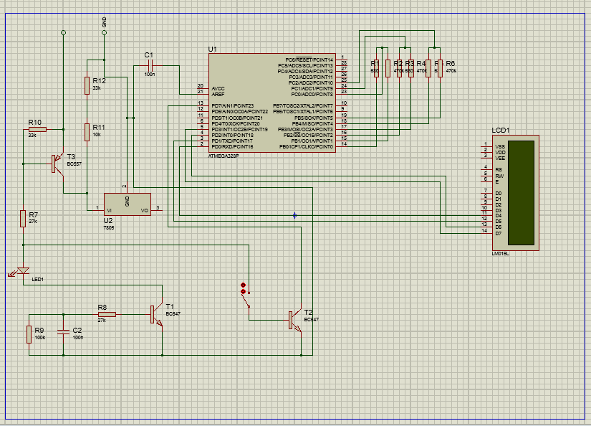
Figure 1: Product Circuit Diagram
The previous method used to check the transistor pin or terminal by using a multi meter. In the lab, student must check the terminal manually before used it for circuit connection. In order to overcome the problem which is checking the terminal manually which sometimes not accurate, the innovation take placed. The process of building the product is based on the simulation of the circuit diagram as shown in Figure 1. The product is designed based basically using normal passive and active component and also including a microcontroller as a processor and a LCD display for displaying the reading and result.

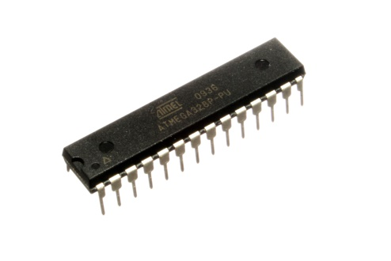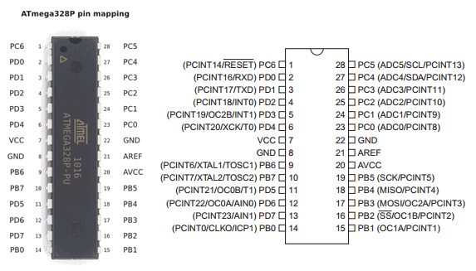
Figure 2: Microcontroller

As the microcontroller ATMega8 was elected. He has more than enough flash and RAM. He also has enough port pins and is very reasonably priced. Transistor Tester is powered by a 9V battery. The 5V operating voltage for the AVR is quite conventionally produced with a 78L05. At Port B of ATMega8 different resistances are connected: The Transistor Pin a large (470 k) and a small (680Ω). Hereby two different currents can be applied to the test pin. The resistors are connected to ADC0, ADC1 and ADC2. On these pins also being tested transistor is connected. The left part of the circuit (the transistors 3) is responsible for the automatic shutdown. More on that later. On the first pins of Port D the LCD is connected. This is a 2x16 character text LCD with HD44780 compatible controller.It should be noted that the test inputs do not have a protective circuit. A protective circuit would probably distort the measurement results. There should therefore be no components which are installed into a circuit tested. Otherwise the ATMega8 could be damaged.

The circuit is undergo several testing and trouble shooting in order to make sure the reading is correct and accurate

. 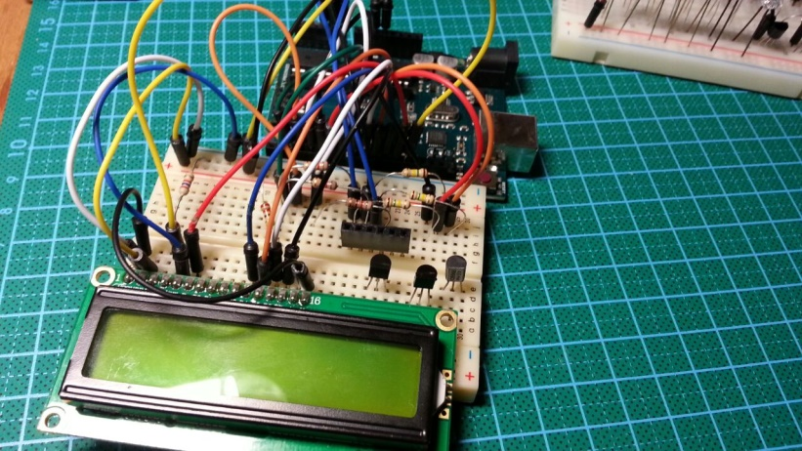
Figure 2: Product Testing and Calibration

3.0 LUKISAN PRODUK
Sertakan lukisan 3D produk perlu di lukis pada sudut-sudut yang berlainan (Perspective view/Front/Back/Top/Rear/Left/Right (side) view.
Nota: Pastikan lukisan jelas, jika gambar pastikan latar belakang berwarna putih.

Rajah 2 : Pandangan Hadapan
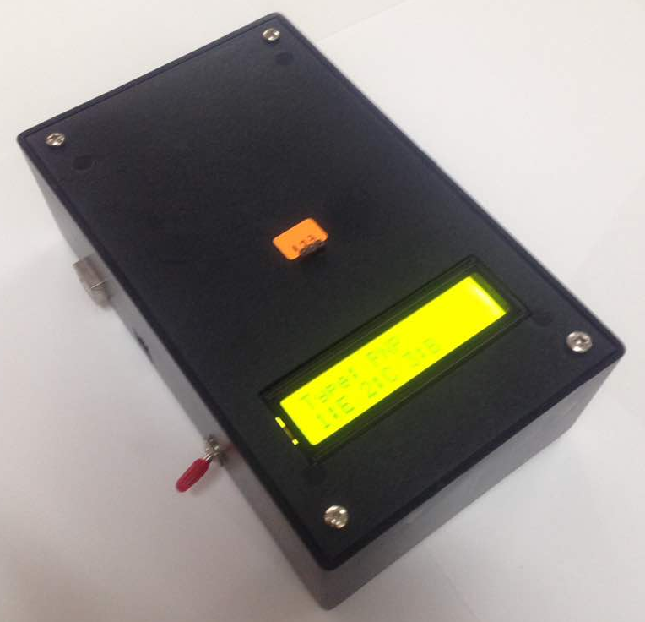

Rajah 2 : Pandangan Atas
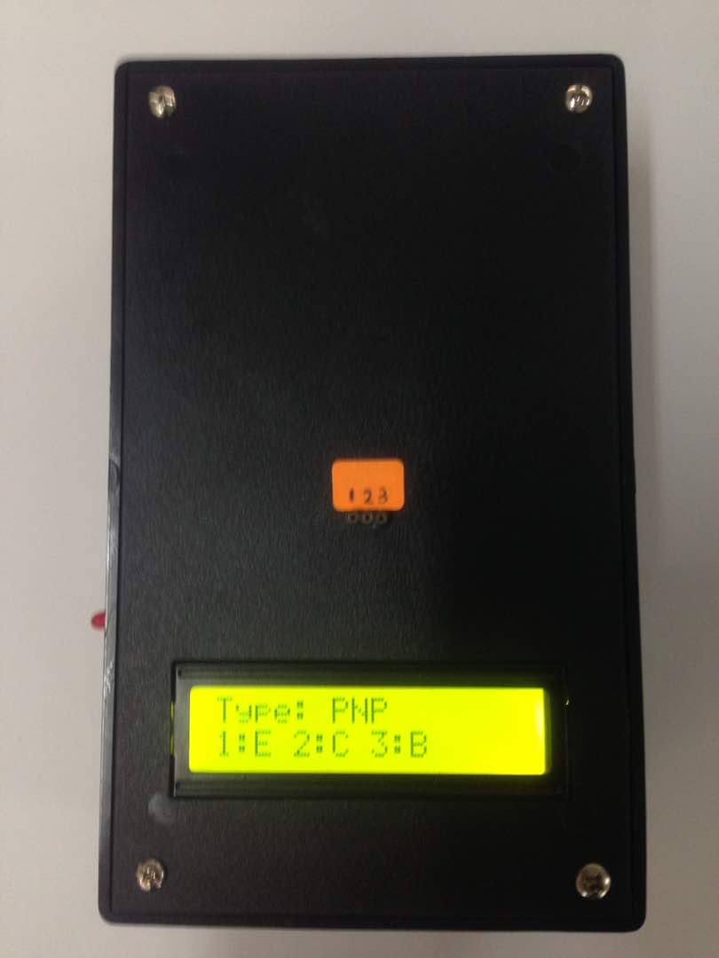

Rajah 3 : Pandangan sisi
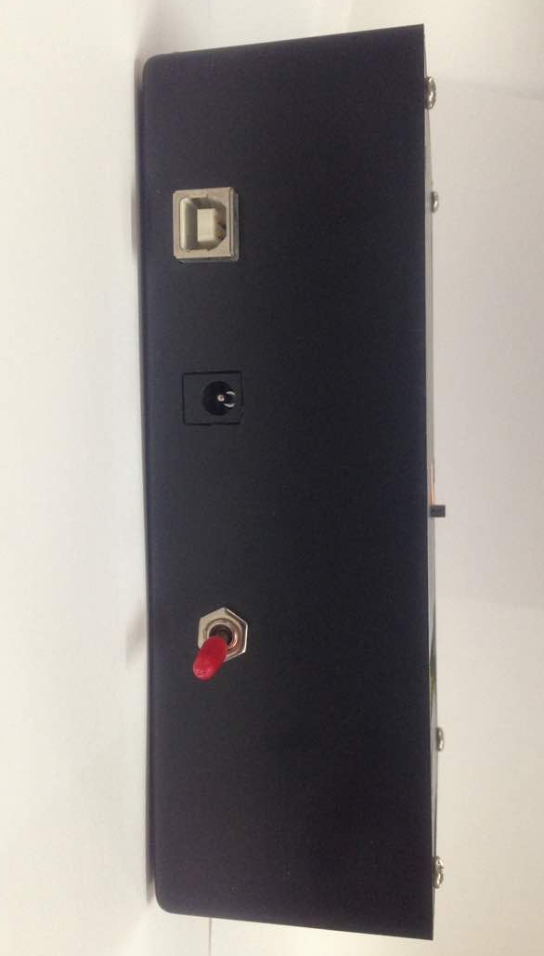

4.0 RUJUKAN / TAMBAHAN MAKLUMAT
Jika melakukan penambahbaikkan produk. Nyatakan rujukan produk tersebut dan sebagainya
Nota: Boleh terdiri dari Jurnal, Manual, Brosur produk terdahulu.
- Tiada –

5.0 SENARAI PEREKACIPTA (INVENTOR)
Inventor 1
Nama penuh : MOHD FAIZ HUSNY BIN YUSOF
No kad Pengenalan : 830130035803
Alamat : POLITEKNIK IBRAHIM SULTAN, PASIR GUDANG, JOHOR
No Telefon : 0127142540
Alamat Email : faizhusny@pis.edu.my

Inventor 2
Nama penuh : MOHD AZALI BIN ZAINAL ABIDIN
No kad Pengenalan : 850724145223
Alamat : POLITEKNIK IBRAHIM SULTAN, PASIR GUDANG, JOHOR
No Telefon : 0196008524
Alamat Email : mohdazali@pis.edu.my

Inventor 2
Nama penuh : ZURAINI BINTI MOHD SAFUAN
No kad Pengenalan : 850801105912
Alamat : POLITEKNIK IBRAHIM SULTAN, PASIR GUDANG, JOHOR
No Telefon : 0177888075
Alamat Email : zuraini@pis.edu.my

6. PENDEDAHAN (disclosure)
Pernahkah inovasi ini didedahkan kepada umum? Jika Ya, nyatakan bentuk pendedahan.
Nota: contoh pendedahan adalah penglibatan dalam pameran samada peringkatan dalaman atau pameran seperti ITEX, Pecipta, MTE. Pengiklanan di media sosial, laporan akhbar dan sebagainya.

- Tiada -

